New New Dis-Eur-England-Kent-Figurine-Seated-Paleolithic-Late Magdalenian

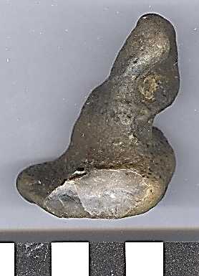 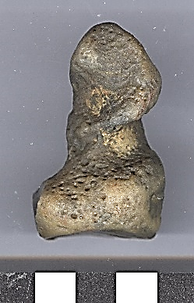 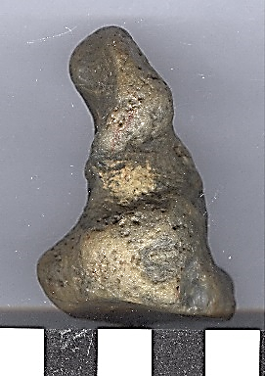

Figs. 1-3. England-Kent-Figurine-Seated-Paleolithic-Late Magdalenian

**Formal Label:** England-Kent-Figurine-Seated-Paleolithic-Late Magdalenian

**Display Description:** This flint nodule figurine comes from near the destroyed flint quarries in Northfleet near Swanscombe and compares with a similar Late Magdalenian flint quarry figurine from Milandes, France**.**

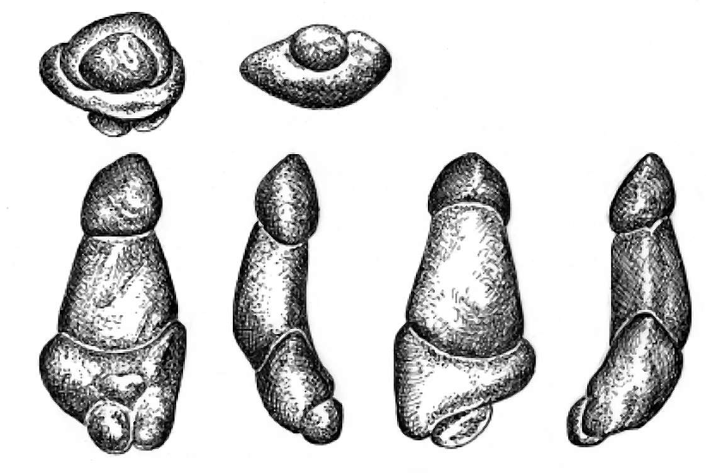 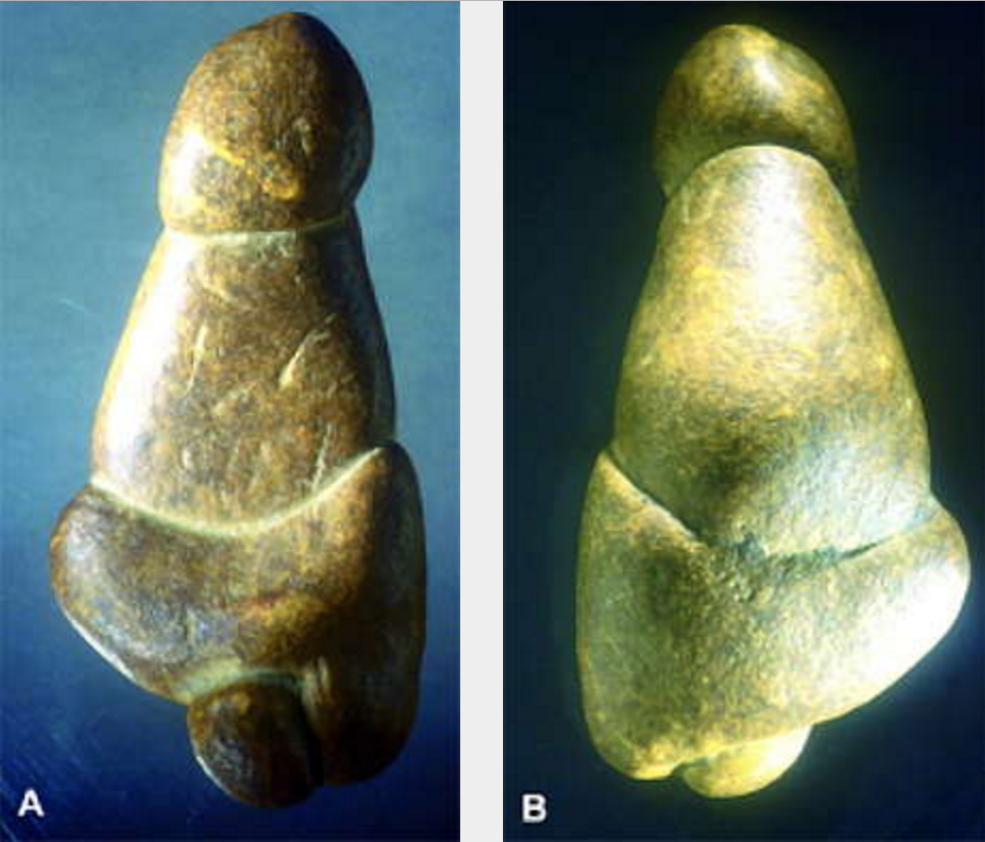

Figs. 4-9. Multiple sketched views of the female (phalliform ?) statuette from Milandes, France. Figs. 10-11. Photographs of figurine. Note especially the views from above. Drawing: S. Castanet. Source: [White (2002)](http://donsmaps.com/milandesvenus.html#reference).

**Accession Number:**

**LC Classification:** GN772.22.G7

**Date or Time Horizon:** Late Magdalenian

**Geographical Area:** Northfleet near Swanscombe, Kent

**Map, GPS Coordinates:** 0.33694, 51.441072; 51° 26' 27.859" N 0° 20' 12.984" E.

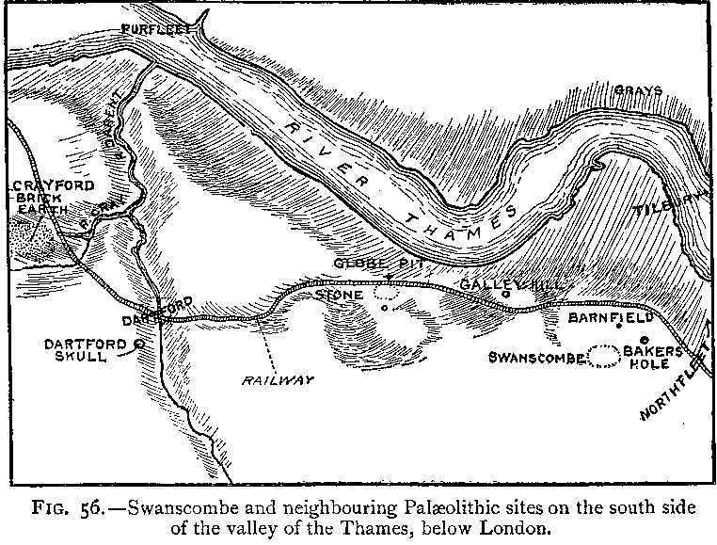

Fig.3. “Swanscombe and neighboring paleolithic sites on the south side of the valley of the Thames, below London,” after Keith 1916, Fig. 56.

Fig. 4. Map of Swanscombe and Northfleet on the south side of the valley of the Thames, below London, up to 1996, where Paleolithic peoples sought flint in the chalk outcrops and areas of quarries. After [LinguisticDemographer](https://en.wikipedia.org/wiki/User:LinguisticDemographer) at [English Wikipedia](https://en.wikipedia.org/wiki/).

**Cultural Affiliation:** Late Magdalinean

**Medium:** Modified flint nodule.

**Dimensions: H cm; W cm.  
Weight:**

**Provenance: English collection of flint artifacts from field walking the Northfleet area.**

**Condition:** original with ancient patination.

**Discussion:** The BM has an apt description of a figurine which ably expresses the value of the present one from Kent. “The present example is a pleasing illustration of the Palaeolithic artist’s ability to appreciate the potential in a natural shape. One break [at the base] and a little chipping here were all that was required to produce a female figure” (Sieveking 1987:60).

**References:**

Conway, Bernard, John McNabb and Nick Ashton, eds.. 1996. *Excavations at Barnfield Pit,* *Swanscombe, 1968-72*; illustrations by Phil Dean. London: Dept. of Prehistoric and Romano-British Antiquities.

Glass, Helen. 2004. “Stone Age elephant remains found,” BBC News, 19 June. <http://news.bbc.co.uk/2/hi/uk_news/england/kent/3821527.stm>. Retrieved 1 Feb 2017.

Keith, Arthur. 1915. *The Antiquity of Man*. London.

Lisiecki, Lorraine E. and Maureen E. Raymo. 2005. “A Pliocene-Pleistocene stack of 57 globally distributed benthic δ18O records,” <http://www.lorraine-lisiecki.com/LR04_MISboundaries.txt>. Retrieved 1 Feb 2017.

## McNabb, John. 2007. *The British Lower Palaeolithic: stones in contention*. London, New York: Routledge.

# Schreve, Danielle C. 2009. “A new record of Pleistocene hippopotamus from River Severn terrace deposits, Gloucester, UK—palaeoenvironmental setting and stratigraphical significance,” *Proceedings of the Geologists' Association*, 120 (1): 58–64.

Sieveking, Ann. 1987. A Catalogue of Palaeolithic Art in the British Museum. London: British Museum

Stringer, Chris. 2006. Homo Britannicus: The incredible story of human life in Britain. London: Penguin.

Tester, P. J. 1984. “Clactonian Flints from Rickson's Pit, Swanscombe,” Archaeologia Cantiana, Kent Archaeological Society. Retrieved 1 Feb 2017.

Warren, S. H. 1922. “The Mesvinian Industry of Clacton-on-Sea,” Proceedings of the Prehistoric Society of East Anglia, 3: 597-602.

White, R. 2002. “Une nouvelle statuette phallo-féminine paléolithique: 'La venus des Milandes' (commune de Castelnaud-la-Chapelle, Dordogne),” *Paleo* N° 14, Décembre, pp. 177-198.